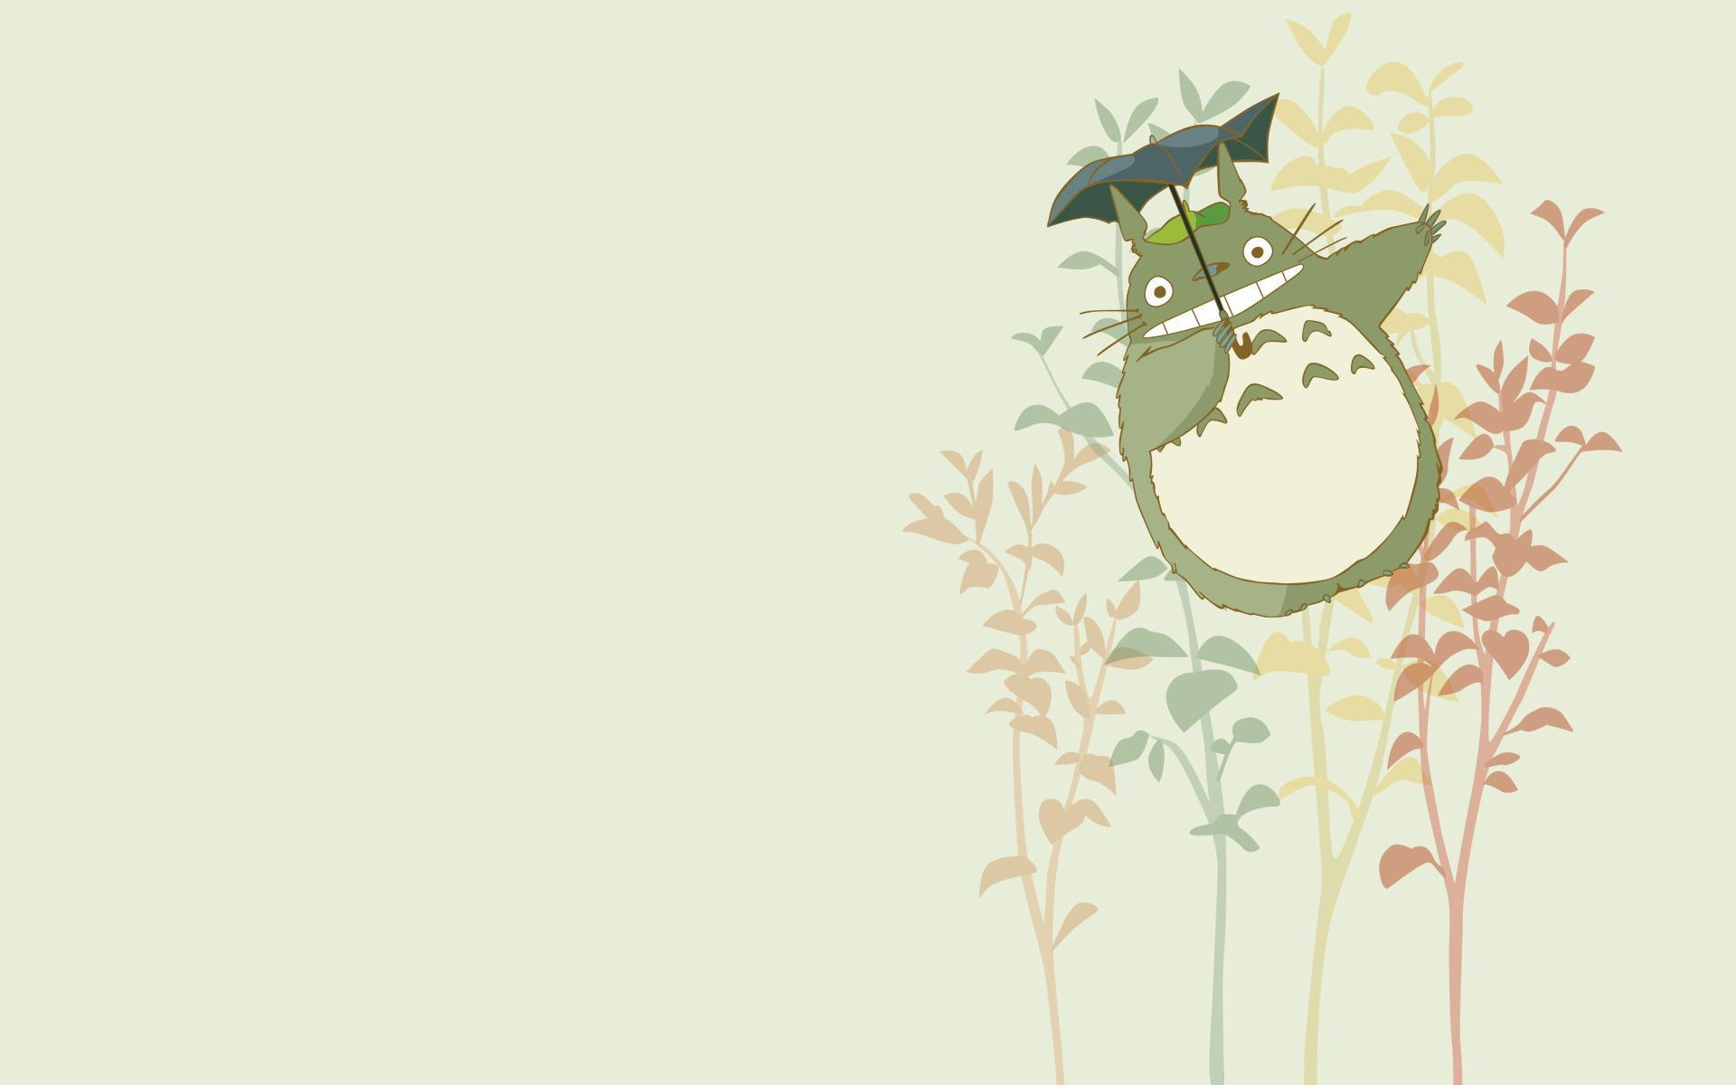
Congratulations on completing my challenge! You have proven that you are the rightful heir to my Bitcoin fortune. While I once owned 1,000,000 bitcoins, I sold them in 2009 when they were worth 0.03 cents each . This earned me a cool $300.
You are now the proud owner of my windfall, which I used to buy a box of novelty stickers and some candy.
Enjoy,
Satoshi
PS: Please only take one sticker and one piece of candy so that others can enjoy my fortune.

Congratulations on completing my challenge! You have proven that you are the rightful heir to my Bitcoin fortune. While I once owned 1,000,000 bitcoins, I sold them in 2009 when they were worth 0.03 cents each . This earned me a cool $300.
You are now the proud owner of my windfall, which I used to buy a box of novelty stickers and some candy.
Enjoy,
Satoshi
PS: Please only take one sticker and one piece of candy so that others can enjoy my fortune.

Reset Instructions:
Step 1: Take a picture of this sheet with your iPad. You will soon be locking it away.
Step 2: Give your teacher your completed puzzles in exchange for a set of fresh copies.
Reset Puzzle #5 (DATA SECURITY): Put the small metal key and the fresh paper into the orange envelope for Puzzle #5. Then put both back under your desk where you found it.
Reset Puzzle #4: Put all transparencies back into the correct manila envelopes (the winning envelope is labeled "THAW"). No papers to reset here (these puzzles were taped to the wall).
Reset Puzzle #3: Put the fresh paper for Puzzle #3 back under the Large Lockbox. If you ripped off the page protector, tape it back on. Put this reset sheet inside the Large Lockbox (don’t forget to take a picture). Put the 4-digit lock (code 4815), the Letter Lock (code CYBER), the Key Lock, and the Directional Lock (code Up Down Left Right Down) back onto the Large Lockbox. To lock them, they need the correct combinations put in. Then scramble the tumblers to lock them.
Reset Puzzle #2: Put the fresh paper for Puzzle #2: Light the Way and the black light flashlight back into the Small Lockbox. Lock the small lockbox using the 3-digit lock (code 319), then scramble the tumbler (or set it to 000).
Reset Puzzle #1: Return the Small Lockbox to your teacher’s desk.

Thanks for playing, and good luck on the test tomorrow! If you enjoyed today’s game, please help your friends enjoy it as much as you did: don’t tell them about today's puzzles!

Reset Instructions:
Step 1: Take a picture of this sheet with your iPad. You will soon be locking it away.
Step 2: Give your teacher your completed puzzles in exchange for a set of fresh copies.
Reset Puzzle #5 (DATA SECURITY): Put the small metal key and the fresh paper into the orange envelope for Puzzle #5. Then put both back under your desk where you found it.
Reset Puzzle #4: Put all transparencies back into the correct manila envelopes (the winning envelope is labeled "THAW"). No papers to reset here (these puzzles were taped to the wall).
Reset Puzzle #3: Put the fresh paper for Puzzle #3 back under the Large Lockbox. If you ripped off the page protector, tape it back on. Put this reset sheet inside the Large Lockbox (don’t forget to take a picture). Put the 4-digit lock (code 4815), the Letter Lock (code CYBER), the Key Lock, and the Directional Lock (code Up Down Left Right Down) back onto the Large Lockbox. To lock them, they need the correct combinations put in. Then scramble the tumblers to lock them.
Reset Puzzle #2: Put the fresh paper for Puzzle #2: Light the Way and the black light flashlight back into the Small Lockbox. Lock the small lockbox using the 3-digit lock (code 319), then scramble the tumbler (or set it to 000).
Reset Puzzle #1: Return the Small Lockbox to your teacher’s desk.

Thanks for playing, and good luck on the test tomorrow! If you enjoyed today’s game, please help your friends enjoy it as much as you did: don’t tell them about today's puzzles!

